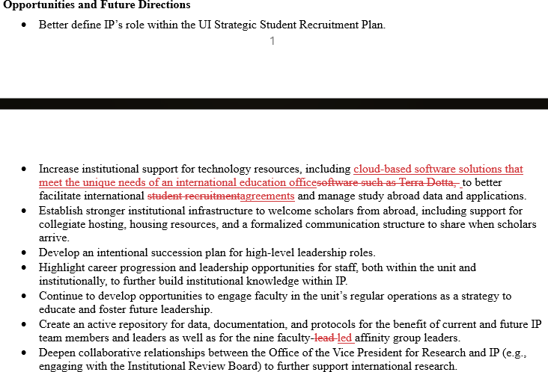
International Programs – Factual corrections to review committee report – April 16, 2025

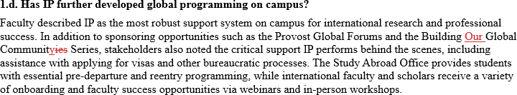
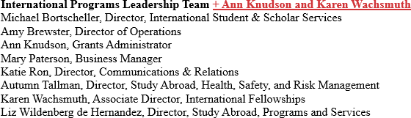

Senior Advisors and Program Coordinators
Emily Bro,vn, Senior Advisor and Program DifeelefCoordinator, Study Abroad Monica Emberger, Assistant Director, £weir Aefead Internships, Study Abroad Ana Jimenez, Senior Advisor and Program Coordinator, StudyAbroad
Teresa Kout, Assistant Director, £weir Aefead Scholarships, Study Abroad
Shuhui Lin, Coordinator, International Education Program & Student Affairs Advisor £ai�eat liiYJ3peft &
:11:agagemeat, International Student & Scholar Services
Kevin Roiseland, Senior Advisor, International Student & Scholar Services

